**From:** Yen Lin Tan [mailto:yen_lin_tan@bd.com]   
**Sent:** Tuesday, 08 July, 2014 8:17 PM  
**To:** Chan, Pei-Fong; Petty Fan  
**Cc:** Niju Ponnapan; Min Yuan Seow; 'Jack Fong' (jack.fong@dbschenker.com); Zhi Ai, Huang  
**Subject:** RE: Print only customer part number on RDC shipping doc

Hello Pei Fong,

I’ve re-looked at the possible number of ship to parties and there are simply too many. As such, I have discussed with Petty that we will use

Country, BD MaterialCode, Customer MaterialCode instead.

Currently, the BD material code have yet to be created. I only have the based part number. This is the equivalent of the customer material to be printed.

When we eventually create the BD part number there will be a 2 digit extended at the back of the number.

Eg 381357**01**

CAT#

381357

381347

381337

381334

381323

381312

400272

400273

As I do not have actual orders for testing now, do you think we can take a few orders from production, twig the ZODL / ZTOL report to amend the original SKU number to test the result ? I would like to test the following scenarios :

1. Order to BD Chennai
2. Trade order – ship to India (CIF)
3. Trade order – FCA Singapore (handover locally in Singapore)

All scenario if we do have variant code orders should only print the 6-digit number on our document.

Thanks.

**Yen-Lin TAN**  
Regional Logistics Manager, Asia Pacific

**BD**  
30 Tuas Avenue 2,   
Singapore 639461,   
Office: +65 6690 8611 Mobile: +65 9734 9818  
Email: [Yen_Lin_Tan@bd.com](mailto:Yen_Lin_Tan@bd.com) Website: [www.BD.com](http://www.bd.com/)

=============================================================

Development, Validate

=============================================================

**From:** Yen Lin Tan   
**Sent:** Thursday, July 10, 2014 4:49 PM  
**To:** 'Chan, Pei-Fong'; Petty Fan; Niju Ponnapan  
**Cc:** Min Yuan Seow; 'Jack Fong' (jack.fong@dbschenker.com); Zhi Ai, Huang  
**Subject:** RE: Print only customer part number on RDC shipping doc

Hello Pei Fong,

Thanks.  Looks good to me.  Internal picklist is showing the 8 digit and customer facing docs (6 –digit).

=============================================================

**Approved:**

=============================================================

**From:** Yen Lin Tan [mailto:yen_lin_tan@bd.com]   
**Sent:** Friday, 01 August, 2014 7:15 PM  
**To:** Chan, Pei-Fong; Petty Fan  
**Cc:** Niju Ponnapan; Min Yuan Seow; Jack, Fong; Zhi Ai, Huang  
**Subject:** RE: Print only customer part number on RDC shipping doc

Hello Pei Fong

Niju has approved . Pls see attached.

**Yen-Lin TAN**

=============================================================

UAT : 13 Aug 2014

Deploy Date : Aug 2014   
=============================================================

**WMS Changes;**

1. Maintain Customer SKU by Country

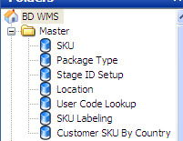

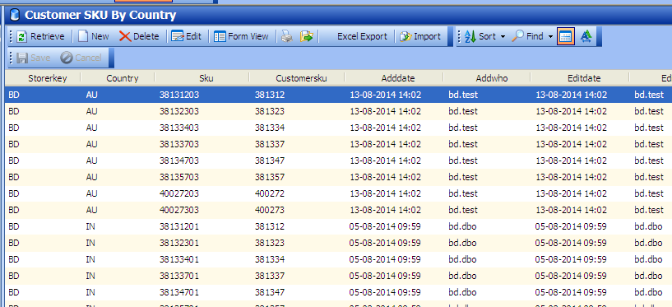

* Country , SKU and Customer SKU

Sample TEST data:

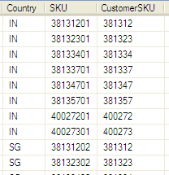

**[Import]**

**File template** in excel format:

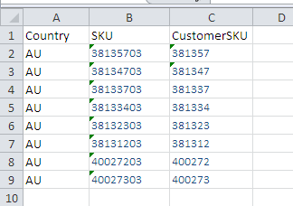

1. **Packing List – mapping to master Customer SKU**

Packing list showing customer SKU - 381337

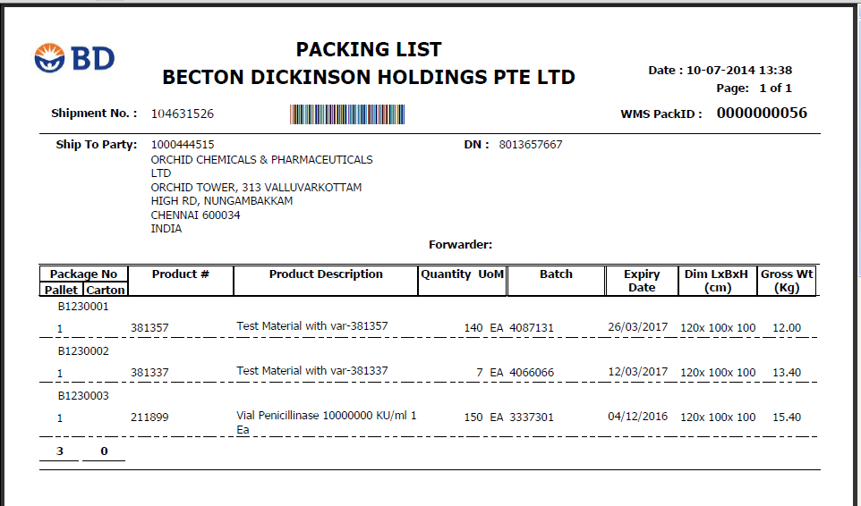

**Pick list showing BD SKU (38133701) – Format no changes**

